PROGRAM ON CONTROL STATEMENTS

1. SUM OF SERIES

Explanation:

Put simply, the sum of a series is the total the list of numbers, or terms in the series, add up to. If the sum of a series exists, it will be a single number (or fraction), like 0, ½, or 99.

The problem of how to find the sum of a series has been around since ancient times. Archimedes’ summation of 1 + 1/4 + 1/42 + … was one of the earliest examples. Some summations were tougher than others; the first “really tough” summation problem was 1 + (1/2)2 + (1/3)2 + …, which Mengoli, and brothers Jakob Bernoulli and Johann Bernoulli tackled without success. It was Euler who found the solution (π2/6) in 1734, long after Jakob Bernoulli had died [1].

Program 1:

#Series 0,2,6,12,....N

n=int(input("Enter the range of number(limit):"))

i=1

while(i<=n):

print((i\*i)-i,end=" ")

i+=1

Output 1:

Enter the range of number(limit):7

0 2 6 12 20 30 42

Program 2:

#Series 0,2,8,14,24,34.....N

n=int(input("Enter the range of number(limit):"))

i=1

pr=0

while(i<=n):

if(i%2==0):

pr=pow(i,2)-2

print(pr,end=" ")

else:

pr=pow(i,2)-1

print(pr,end=" ")

i+=1

Output 2:

Enter the range of number(limit):8

0 2 8 14 24 34 48 62

Program 3:

#Series 1 4 7 10......N

n=int(input("Enter the range of number(limit):"))

i=1

while(i<=n+1):

print(i)

i=i+3

print("It's the series")

Output 3:

Enter the range of number(limit):40

1

4

7

10

13

16

19

22

25

28

31

34

37

40

It's the series

Program 4:

#Series 1^3+2^3+3^3....N^3

n=int(input("Enter the value:"))

res=0

for i in range(1,n+1):

res=res+(i\*i\*i)

print("Series:",res)

Output 4:

Enter the value:4

Series: 100

Program 5:

#Series 2+4+6+....N

n=int(input("Enter the range of number:"))

sum=0

i=0

while(i<=n):

sum+=i

i+=2

print("Series:",sum)

Output 5:

Enter the range of number:12

Series: 42

Program 6:

#Series 1+11+111+1111...N

n=int(input("Enter the number of term:"))

s=0

sum1=0

print("Series are",end=" ")

for i in range(0,n):

s=s\*10+1

print(s,end=" ")

sum1=sum1+s

print()

print("Series sum=",sum1)

Output 6:

Enter the number of term:5

Series are 1 11 111 1111 11111

Series sum= 12345

Program 7:

#Series 9+99+999+9999...N

n=int(input("Enter the number of term:"))

s=0

sum1=0

print("Series are",end=" ")

for i in range(0,n):

s=s\*10+9

print(s,end=" ")

sum1=sum1+s

print()

print("Series sum=",sum1)

Output 7:

Enter the number of term:5

Series are 9 99 999 9999 99999

Series sum= 111105

Program 8:

#Fibonacci series

n = int(input("Enter the value of 'n': "))

a = 0

b = 1

sum = 0

count = 1

print("Fibonacci Series: ", end = " ")

while(count <= n):

print(sum, end = " ")

count += 1

a = b

b = sum

sum = a + b

Output 8:

Enter the value of 'n': 8

Fibonacci Series: 0 1 1 2 3 5 8 13

Program 9:

#Series 1/2!+2/3!+3/4!.....N/(N+1)!

s=0

f=1

n=int(input("Enter the number:"))

for i in range(1,n+1):

f=(f+1)\*i

s=s+(i/f)

print(s)

Output 9:

Enter the number:5

1.0328809767012013

Program 10:

#Series 1+3+5+7...N

print("Enter the range of number:")

n=int(input())

sum=0

i=1

while(i<=n):

sum+=i

i+=2

print("Series:",sum)

Output 10:

Enter the range of number:51

Series: 676

Program 11:

#Series 1+2+3+4+....N

n=int(input("Enter the value:"))

sum=0

for i in range(1,n+1):

sum+=i

print("Series:",sum)

Output 11:

Enter the value:9

Series: 45

Program 12:

#Series 1!+2!+3!....N!

n=int(input("Enter the value:"))

fact=1

for i in range(1,n+1):

fact=fact\*i

print(fact)

Output 12:

Enter the value:5

120

2.NUMBER PATTERN

Explanation:

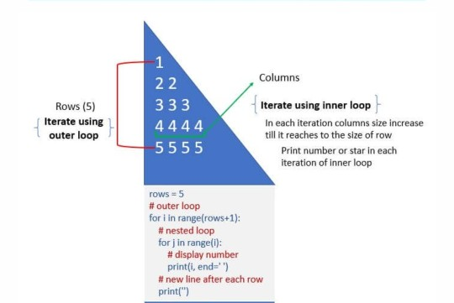

Program 1:

#Number pattern 1

n=int(input("Enter the number of rows:"))

for i in range(n):

for j in range(i):

print(i,end=" ")

print(" ")

Output 1:

Enter the number of rows:6

1

2 2

3 3 3

4 4 4 4

5 5 5 5 5

Program 2

#Number pattern 2

n=int(input("Enter the number of rows:"))

for i in range(1,n+1):

for j in range(1,i+1):

print(j,end=' ')

print(" ")

Output 2:

Enter the number of rows:5

1

1 2

1 2 3

1 2 3 4

1 2 3 4 5

Program 3:

#Number pattern 3

n=int(input("Enter the number of rows:"))

b=0

for i in range(n,0,-1):

b+=1

for j in range(1,i+1):

print(b,end=" ")

print('\r')

Output 3:

Enter the number of rows:5

1 1 1 1 1

2 2 2 2

3 3 3

4 4

5

Program 4:

#Number pattern 4

n=int(input("Enter the number of rows:"))

for i in range(n):

for j in range(i,n):

print('5',end=" ")

print()

Output 4 :

Enter the number of rows:5

5 5 5 5 5

5 5 5 5

5 5 5

5 5

5

Program 5:

#Number pattern 5

n=int(input("Enter the number of rows:"))

i=1

while(i<=n):

j=1

while(j<=i):

print((i\*2-1),end=" ")

j=j+1

i=i+1

print("")

Output 5:

Enter the number of rows:5

1

3 3

5 5 5

7 7 7 7

9 9 9 9 9

Program 6:

#Number pattern 6

n=int(input("Enter the number of rows:"))

for i in range(1,n):

for j in range(i,0,-1):

print(j,end=" ")

print(" ")

Output 6:

Enter the number of rows:6

1

2 1

3 2 1

4 3 2 1

5 4 3 2 1

3.PYRAMID PATTERN

Explanation:

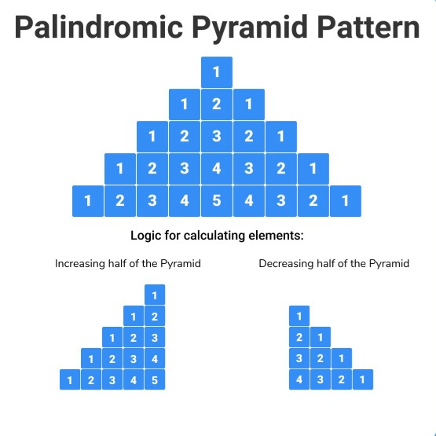

Program 1:

#Pyramid pattern 1

n=int(input("Enter the number of rows:"))

for i in range(0,n):

for j in range(0,i+1):

print('\*',end=" ")

print("\r")

Output:

Enter the number of rows:5

\*

\* \*

\* \* \*

\* \* \* \*

\* \* \* \* \*

Program 2:

#Pyramid pattern 2

n=int(input("Enter the number of rows:"))

for i in range(n+1,0,-1):

for j in range(0,i-1):

print('\*',end=" ")

print(" ")

Output 2:

Enter the number of rows:5

\* \* \* \* \*

\* \* \* \*

\* \* \*

\* \*

\*

Program 3:

#Pyramid pattern 3

n=int(input("Enter the number of rows:"))

for i in range(n):

for j in range(i):

print(" ",end="")

for j in range(n-i):

print("\*",end=" ")

print(" ")

Output 3:

Enter the number of rows:6

\* \* \* \* \* \*

\* \* \* \* \*

\* \* \* \*

\* \* \*

\* \*

\*

Program 4:

#Pyramid pattern 4

n=int(input("Enter the number of rows:"))

for i in range(n):

for j in range(i):

print(" ",end="")

for j in range(n-i):

print("\*",end=" ")

print(" ")

Output 4:

Enter the number of rows:5

\* \* \* \* \*

\* \* \* \*

\* \* \*

\* \*

\*

Program 5:

#Pyramid pattern 5

n=int(input("Enter the number of rows:"))

m=(2\*n)-2

for i in range(0,n):

for j in range(0,m):

print(end=" ")

m=m-1

for j in range(0,i+1):

print("\*",end=' ')

print(" ")

Output 5:

Enter the number of rows:6

\*

\* \*

\* \* \*

\* \* \* \*

\* \* \* \* \*

\* \* \* \* \* \*

Program 6:

#Pyramid pattern 6

n=int(input("Enter the number of rows:"))

for i in range(0,n):

for j in range(0,i+1):

print("\*",end=" ")

print("\r")

for i in range(n,0,-1):

for j in range(0,i-1):

print("\*",end=" ")

print("\r")

Output 6:

Enter the number of rows:5

\*

\* \*

\* \* \*

\* \* \* \*

\* \* \* \* \*

\* \* \* \*

\* \* \*

\* \*

\*

4.PROGRAMS ON CONDITIONS

Explanation:

Decimal numbers:

A decimal is a number that consists of a whole and a fractional part. Decimal numbers lie between integers and represent numerical value for quantities that are whole plus some part of a whole.

Binary numbers:

A binary number system is one of the four types of number system. In computer applications, where binary numbers are represented by only two symbols or digits, i.e. 0 (zero) and 1(one). The binary numbers here are expressed in the base-2 numeral system. For example, (101)2 is a binary number. Each digit in this system is said to be a bit.

Armstrong number:

An Armstrong number is a number such that the sum ! of its digits raised to the third power is equal to the number ! itself. For example, 371 is an Armstrong number, since ! 3\*\*3 + 7\*\*3 + 1\*\*3 = 371. !

Reversing a number:

Reversing a number means changing all the digits of a number to bring the digit at the last position to the first position and vice-versa

Prime number:

Prime numbers are numbers that have only 2 factors: 1 and themselves. For example, the first 5 prime numbers are 2, 3, 5, 7, and 11.

Leap year:

To be a leap year, the year number must be divisible by four – except for end-of-century years, which must be divisible by 400

Program 1:

#Decimal to binary

n=int(input("Enter the number:"))

sum=0

while(n>0):

r=n%2

sum=sum\*10+r

n=n//2

print(sum)

Output 1:

Enter the number:46

11101

Program 2:

#Binary to decimal

n=int(input("Enter the num:"))

num=n

sum=0

base=1

while(n>0):

rem=n%10

sum=sum+rem\*base

n=n//10

base=base\*2

print(sum)

Output 2:

Enter the num:1101

13

Program 3:

#Armstrong number

n=int(input("Enter the num:"))

num=n

sum=0

while(n>0):

rem=n%10

sum=sum+(rem\*\*3)

n=n//10

if(sum==num):

print("Armstrong number")

else:

print("Not Armstrong number")

Output 3:

Enter the num:153

Armstrong number

Program 4:

#Reversing a number

n=int(input("Enter the num:"))

num=n

sum=0

while(n>0):

rem=n%10

sum=(sum\*10)+rem

n=n//10

print(sum)

Output 4:

Enter the num:153

351

Program 5:

#Prime numbers between 1 to 50

start=int(input("Enter the lower bound:"))

stop=int(input("Enter the upper bound:"))

print("Prime numbers are:")

for n in range(start,stop):

if(n>1):

for i in range(2,n):

if(n%i)==0:

break

else:

print(n,end=" ")

Output 5:

Enter the lower bound:1

Enter the upper bound:50

Prime numbers are:

2 3 5 7 11 13 17 19 23 29 31 37 41 43 47

Program 6:

#Leap year between 1900 to 2000

start=int(input("Enter the lower bound year:"))

stop=int(input("Enter the higher bound year:"))

years=[]

for year in range(start,stop+1):

if (year%400==0):

years.append(year)

elif ((year%4==0)and(year%100!=0)):

years.append(year)

print(years)

Output 6:

Enter the lower bound year:1900

Enter the higher bound year:2000

[1904, 1908, 1912, 1916, 1920, 1924, 1928, 1932, 1936, 1940, 1944, 1948, 1952, 1956, 1960, 1964, 1968, 1972, 1976, 1980, 1984, 1988, 1992, 1996, 2000]

Web reference :

<https://www.programiz.com/python-programming/examples>

<https://pynative.com/python-exercises-with-solutions/>

<https://www.geeksforgeeks.org/python-programming-language/>